Linking Integration Services and Reporting Services
in SQL Server 2008 R2

This document describes a simple example of event-based notification involving an Integration Services component and a Reporting Services component, with a metadata table in between to define the linkages. In this approach, we call the rs.exe utility from within Integration Services to set the start time of a Reporting Services shared schedule. Any reports that subscribe to the shared schedule will be executed once the schedule is started. This example covers the several technology components and is metadata driven; it requires prior experience with Reporting Services, the relational database, and Integration Services.

Reporting Services Setup
1. Use Management Studio (or click on Site Settings in Report Manager in the browser) to create a new shared schedule. Name the shared schedule in a way that describes the event it represents, like the Orders Data Load Complete schedule shown in Figure 1. Set the Recurrence Pattern Type to execute Once at a start time already past.

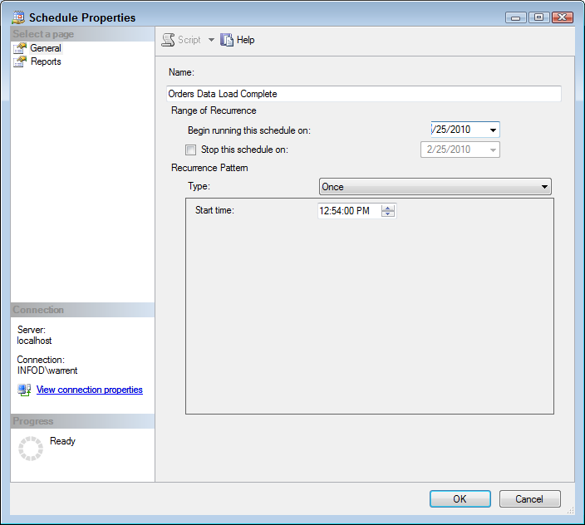
Figure 1 – The Orders Data Load Complete schedule properties window in SQL Server Management Studio

2. Create a subscription that ties a report to the shared schedule by selecting Subscribe… from the dropdown menu of each report in the Report Manager (or, select Manage from the dropdown menu and then Subscriptions). See Figure 2 for an example of the subscription specification page.

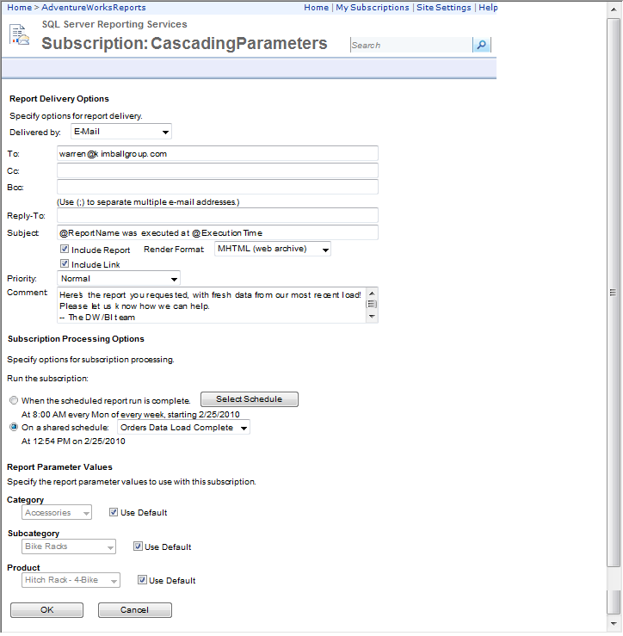
Figure 2 – Report subscription based on the Orders Data Load Complete schedule

Note that the data sources used by your reports will need to be set to use stored credentials -- usually the reporting admin account. You can set this in the general properties of the data source in Report Manager (see Figure 3). Make sure you don't overwrite this the next time you deploy the data source.

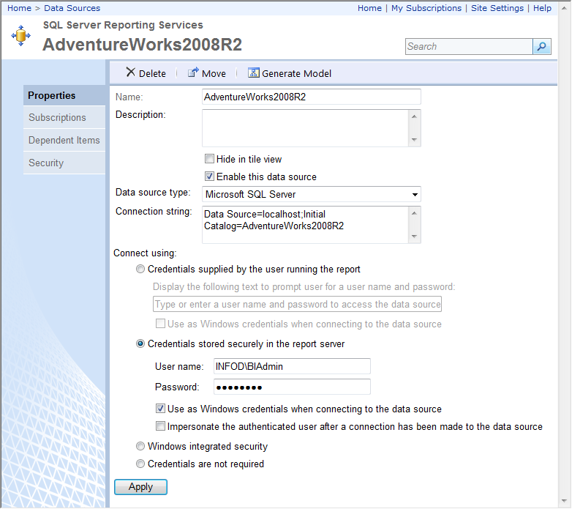
Figure 3 – Storing the data source connection credentials

3. If your report is set to render from an execution snapshot, you will need to make sure the snapshot is updated based on the schedule. Choose Manage from the report’s dropdown menu and then choose the Snapshot Options tab. Check the Use the following schedule… checkbox, and choose the shared schedule created in Step 1 from the pull-down menu (for example, Orders Data Load Complete). This is how the schedule causes the snapshot to be created. If you are creating snapshots, you should set up your report subscriptions to run when the report is refreshed. Reporting services will generate the snapshot based on the schedule and then run the reports once the snapshot is refreshed. Otherwise, the reports may run before the snapshot is refreshed.
4. When your Integration Services package causes the shared schedule to run, all reports (and snapshots) linked to that schedule will execute.
5. For enterprise report distribution, the administrator should set up master subscriptions using the data-driven subscription feature to send reports to email distribution lists.

Database Setup
You need to create and populate a table named ETL_Job_To_RS_Schedule_Map that sits between Reporting Services and Integration Services as shown in Figure 4. This table allows you to start multiple schedules from the same ETL package and can link a particular load name to any number of schedules. In the example dataset shown in Figure 4, the Orders Data Load ETL job is linked to two schedules. Each of these schedules may invoke several reports in Reporting Services as described in the Reporting Services setup section.

The ETL_Job_Type column allows you to define the context of a given Integration Services package execution. For example, the ETL_Job_Type named Test allows the Integration Services package to run in test mode to test the entire process. The schedule associated with the Test ETL_Job_Type is linked to only a few reports that are sent to the developers. Without this flag, everyone will receive a full set of reports every time the Integration Services package is run, even if it’s a test run. Once the process is tested and ready for production, you can add an entry in the ETL_Job_To_RS_Schedule_Map table with ETL_Job_Type = 'Regular'.

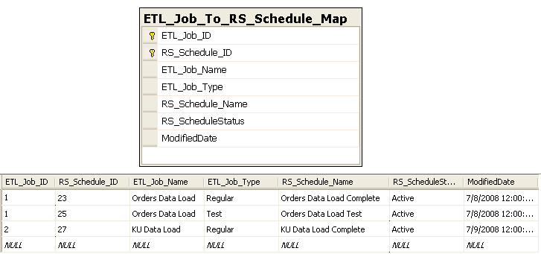

Figure 4 – The ETL_Job_To_RS_Schedule_Map table and example rows

To create the ETL_Job_To_RS_Schedule_Map table, run the Create ETL_Job_To_RS_Schedule_Map Script.sql script in the Load Event Files folder. We generally create the table in the ETL staging database or the data warehouse metadata database. In this example, we are using DW_Metadata.

Integration Services Setup
On the Integration Services side, each load package should execute a shared Report Initiation package at the end of its successful completion. The ETL load package will need to pass a few parameters to the Report Initiation package, including ETL_Job_Name, and ETL_Job_Type. See Chapter 7 for a discussion of how to communicate between Integration Services packages.

There are several steps to get the example working:
- Copy the SetSchedule.rss script file to the working directory of the package, which is C:\MDWT_Projects\Load Events Trigger.
- Open the RS Link Test solution.
- Open the Report Initiator package and save it to the SQL Server package library.
- Open the RS Link Test Pkg and open the Execute Package task named “Execute Report Initiator package”.
- Select the Package properties, then select in the Package Name box, and navigate to the Report Initiator package you just saved in step 3.
- Set the variables in the parent package (RS Link Test Pkg).

The Report Initiator package uses the ETL_Job_Name and ETL_Job_Type variables in an Execute SQL task ( to select the list of Schedules that need to be initiated from the ETL_Job_To_RS_Schedule_Map table. It then uses the Execute Process task to call the rs.exe utility and run a script that uses the Reporting Services object model and API to set each schedule to run in the next few minutes.

NOTE: rs.exe is part of native-mode Reporting Services it is not available in SharePoint integrated mode. Instead, you need to use the SharePoint SOAP endpoint for application access to reporting services functions. We may post instructions for the SharePoint version on the book's website when we figure out how to make it work. Let us know if you figure it out!

Setting up the Execute Process Task
First, make sure the rs.exe file location is in the Path environment variable. As Figure 5 shows, the Arguments property is the command line that invokes the script. In this example, the full command line to start a single schedule is:

-i SetSchedule.rss -s http://Localhost/Reportserver -v SchedName="Orders Data Load Complete"

Since this example is designed to allow a single job to initiate multiple schedules, we used the ForEach container in Integration Services and fed in a list of schedules. The Argument property is then set using the Expressions pane with the following expression:

"-i SetSchedule.rss -s " + @[User::Report_Server_URL] + " -v SchedName=\"" + @[User::Current_Schedule_Name] + "\""

Note the use of the backslash character to enable printing of the quote in the string.

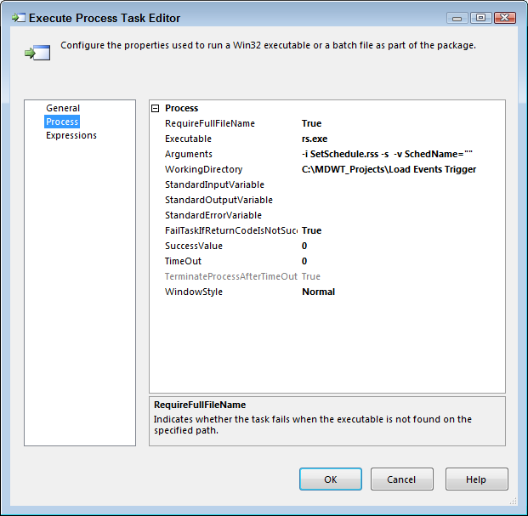
Figure 5 – Execute Task Editor

The file containing the script is named SetSchedule.rss. In Figure 5, it is found in the Reporting Services Scripts directory. SetSchedule.rss is part of the download file set, and the path for its location on your system goes in the WorkingDirectory property.

Alternate Approach
If you don’t like using rs.exe, you might try working with some of the stored procedures in the ReportServer database. These are not documented in BOL, presumably because Microsoft does not want to have to support them. If you’d like to try this approach, you’ll need to change the ETL_Job_To_RS_Schedule_Map to include the ScheduleID GUID from the Schedule table in the ReportService database. You could then code the entire loop in an Execute SQL Task using a WHILE loop and the following EXEC statement (with appropriate substitutions):
Exec dbo.UpdateScheduleNextRunTime 'C9092F2E-D56C-48BE-8EDE-1D7A7CCA010D', '8/13/2008 2:16 PM'

Enhancements
These instructions describe a basic linkage system between Integration Services and Reporting Services. There are many enhancements you might consider from here. For example, you may want to get clever and include a priority value in the ETL_Job_To_RS_Schedule_Map table. The script could then stagger the start time for each schedule, depending on its priority.

Please let us know what kinds of enhancements you include in your version.

Thanks,
-- Warren Thornthwaite

